Type-C Female to OTG (On-The-Go) USB3 Conversion Adapter
Connect your regular USB flash drives, mouse, keyboard to your
AndroidTM or AppleTM device or notebook via regular USB connections
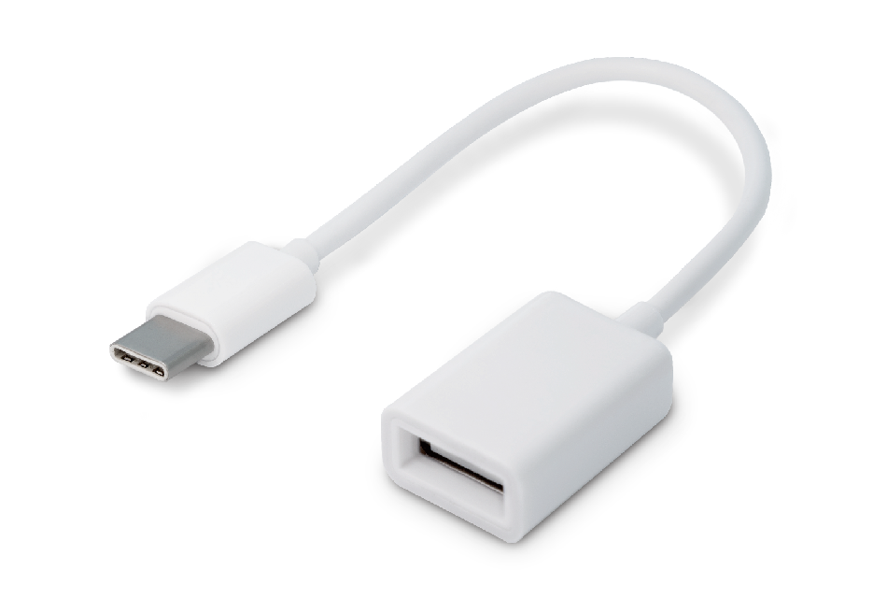

Descrption:
Want to connect your regular USB-type keyboard, mouse, flash drive or other USB peripheral into your Type-C connected AndroidTM or MacBookTM notebook, tablet or other Type-C smartphone.
Simply plug our adapter the OTG (On-The-Go) adapter into a vacant Type-C port on your AndroidTM or AppleTM device and then connect your existing USB peripheral and work away. Compatible with most USB peripherals and generally no drivers will be needed.
Compact and a must-have adapter for almost all USB devices you have and you'll wonder how you ever managed without it.

Features:
- Type-c OTG adapter small and light, easy to carry
- Connection handle mobile phone to handle game machine no touch screen for more fun
- Connecting to a type-c computer give MacBook a new way to play easy implementation of type-c notebook connection u disk ,mouse ,keyboard,printer and other devices
- The type-c interface is special and suitable for various devices
- Double sided interface, regardless of positive and negative interface
- PVC ma terial more flexible body the outer skin of wire rod adopts environmental protection wire rod, which is strong and durable, not easy to deform,and has a longer service life.

Specifications
- Material：PVC
- Color: White
- Cable: 10cm
- Transmission: USB3.0 14MB-16MB/S
- Compatibility: Pad with USB-C port; Smartphone or tablet with USB-C port and OTG; PC and laptop with USB-C port.
- Digital Camera, Audio/MIDI interfaces, Keyboard, and so on.
- Certificate: CE FCC ROHS
- Operating Temperature:0℃ to +45℃
- Operating Humidity:10%0 to 85 % RH
- Storage Temperature : -10℃ to +55℃
- Storage Humidity: 5% to 90 % RH

Product Code:
Part number: C-TC-OTG
Barcode：8400800036681
Size: 135mm*19.8mm*11.3mm (L*W*H)
Weight: 9g

